Proiect la Baze de Date in Economie

Banci

Bancomat

Danci Anca Denisa

Informatica Economica, an II, grupa III

2020-2021

**Scenariu**

In cadrul acestei baze de date este surprinsa activitatea bancilor in legatura cu bancomatele.

Fiecare banca are un sediu central de care apartin una sau mai multe agentii din diverse locatii. Tot de banca, apartin si bancomatele care se pot afla si in afara agentiilor. Acestea au o limita de bani cash care se pot retrage zilnic, dar aceasta difera in functie de politica bancii respective. Un bancomat poate opera mai multi clienti, dar de asemenea si un client poate folosi mai multe bancomate. In baza de date retinem date despre client cum ar fi nume, CNP, adresa si numar de telefon. Un client poate efectua una sau mai multe tranzactii la bancomat. Fiecare client detine unul sau mai multe conturi, fie in lei sau euro, acestea identificandu-se prin codul IBAN. Pentru a putea realiza operatiuni in cadrul unui bancomat si nu numai, fiecare cont poate avea unul sau mai multe carduri, insa nu pot exista doua carduri cu acelasi nume de detinator asignate unui singur cont.

**Diagrama ERD**

**BANCA**

#b_id

*b_denumire

*b_adresa

**AGENTIE**

#a_id

*a_denumire

*a_adresa

**ATM**

#ATM_id

*limita_cash

*locatie

**CONT**

#IBAN

*tip_cont

*sold_cont

**CLIENT**

#c_id

*c_nume

*CNP

*c_adresa

*nr_telefon

**TRANZACTIE**

#tr_id

*data_ora

*tr_tip

* tr_valoare

**CARD**

#nr_card

*tip_card

*CVV

*data_expirarii

*PIN

**M:M**

**Tabele de mapare**

|  |  |  |  |
| --- | --- | --- | --- |
| **BANCI(BCA)** | | |  |
| **Tip cheie** | **Optionalitate** | **Nume coloana** | **Observatii** |
| CP | * | b_id |  |
|  | * | b_denumire |  |
|  | * | b_adresa |  |

|  |  |  |  |
| --- | --- | --- | --- |
| **AGENTII(AGE)** | | |  |
| **Tip cheie** | **Optionalitate** | **Nume coloana** | **Observatii** |
| CP | * | b_id | Cod unic de identificare a institutiilor bancare BIC (4 caractere) |
|  | * | b_denumire | Denumire banca |
|  | * | b_adresa | Adresa sediu central banca |
| CS | * | a_banca | Relatia cu Banci(BCA) |

|  |  |  |  |
| --- | --- | --- | --- |
| **ATM** | | |  |
| **Tip cheie** | **Optionalitate** | **Nume coloana** | **Observatii** |
| CP | * | ATM_id |  |
|  | * | limita_cash |  |
|  | * | locatie |  |
| CS | * | ATM_banca | Relatia cu Banci(BCA) |

|  |  |  |  |
| --- | --- | --- | --- |
| **CLIENTI(CET)** | | |  |
| **Tip cheie** | **Optionalitate** | **Nume coloana** | **Observatii** |
| CP | * | c_id |  |
|  | * | c_nume |  |
| CU | * | CNP |  |
|  | * | c_adresa |  |
|  | * | nr_telefon |  |

|  |  |  |  |
| --- | --- | --- | --- |
| **TRANZACTII(TZE)** | | |  |
| **Tip cheie** | **Optionalitate** | **Nume coloana** | **Observatii** |
| CP | * | tr_id | Id tranzactie |
|  | * | data_ora | Data si ora la care s-a finalizat tranzactia |
|  | * | tr_tip |  |
|  | ⃝ | tr_valoare | Nu intotdeauna poate avea o valoare deoarece la bancomat se pot face si operatiuni care nu reprezinta o suma (de exemplu schimbare pin) |
| CS | * | tr_client | Relatia cu Clienti(CET) |
| CS | * | tr_ATM | Relatia cu ATM |

|  |  |  |  |
| --- | --- | --- | --- |
| **CONTURI(COT)** | | |  |
| **Tip cheie** | **Optionalitate** | **Nume coloana** | **Observatii** |
| CP | * | IBAN |  |
|  | * | tip_cont | Lei/euro |
|  | * | sold_cont |  |
| CS1 | * | client_cont | Relatia cu Clienti(CET) |
| CS2 | * | banca_cont | Relatia cu Banci(BCA) |

|  |  |  |  |
| --- | --- | --- | --- |
| **CARDURI(CAD)** | | |  |
| **Tip cheie** | **Optionalitate** | **Nume coloana** | **Observatii** |
| CP | * | nr_card | 16 caractere |
|  | * | tip_card | Visa/Mastercard/Ominpass |
|  | * | CVV | 3 cifre |
|  | * | data_expirarii |  |
|  | * | pin | 4 cifre |
|  | * | nume_detinator | Pentru acelasi IBAN nu trebuie sa existe 2 carduri cu acelasi nume |
| CS | * | Card_IBAN | Relatia cu Conturi(COT) |

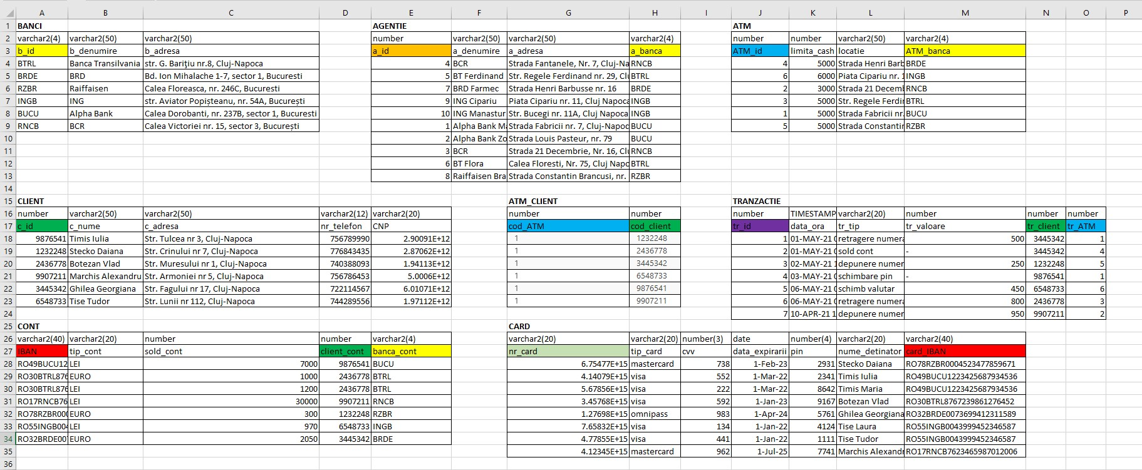**SCHEMA BAZEI DE DATE NORMALIZATA**

**CONSTRANGERI LEGATE DE CAMPURI**

ALTER TABLE Card

ADD CONSTRAINT nr_card_CK CHECK (LENGTHB(nr_card)=16);

ALTER TABLE Card

ADD CONSTRAINT cvv_valid_ck CHECK (cvv between 100 and 999);

ALTER TABLE Card

ADD CONSTRAINT pin_valid_ck CHECK (pin between 1000 and 9999);

ALTER TABLE Client

ADD CONSTRAINT cnp_unique UNIQUE (cnp);

**CREARE TABELE**

* **Creare tabela Banca**

CREATE TABLE Banca (

b_id varchar2(4),//cod bic

b_denumire varchar2(50) NOT NULL,

b_adresa varchar2(50)

);

ALTER TABLE Banca

ADD CONSTRAINT Banca_PK PRIMARY KEY (b_id);

* **Creare tabela Agentie**

CREATE TABLE Agentie (

a_id number,

a_denumire varchar2(50) NOT NULL,

a_adresa varchar2(50),

a_banca varchar2(4) NOT NULL

);

ALTER TABLE Agentie

ADD CONSTRAINT Agentie_PK PRIMARY KEY (a_id);

ALTER TABLE Agentie

ADD CONSTRAINT Agentie_FK

FOREIGN KEY (a_banca)

REFERENCES Banca (b_id);

CREATE SEQUENCE Agentie_seq

START WITH 1

INCREMENT BY 1

NOCACHE

NOCYCLE;

CREATE OR REPLACE TRIGGER Agentie_trg

BEFORE INSERT ON Agentie

FOR EACH ROW

BEGIN

  SELECT Agentie_seq.NEXTVAL

  INTO   :new.a_id

  FROM   dual;

END;

* **Creare tabela ATM**

CREATE TABLE ATM (

ATM_id number,

limita_cash number,

locatie varchar2(50),

ATM_banca varchar2(4) NOT NULL

);

ALTER TABLE ATM

ADD CONSTRAINT ATM_PK PRIMARY KEY (ATM_id);

ALTER TABLE ATM

ADD CONSTRAINT ATM_FK

FOREIGN KEY (ATM_banca)

REFERENCES Banca (b_id);

CREATE SEQUENCE ATM_seq

START WITH 1

INCREMENT BY 1

NOCACHE

NOCYCLE;

CREATE OR REPLACE TRIGGER ATM_trg

BEFORE INSERT ON ATM

FOR EACH ROW

BEGIN

  SELECT ATM_seq.NEXTVAL

  INTO   :new.ATM_id

  FROM   dual;

END;

* **Creare tabela Client**

CREATE TABLE Client (

c_id number,

c_nume varchar2(50) NOT NULL,

c_adresa varchar2(50) NOT NULL,

nr_telefon varchar2(12) NOT NULL,

CNP varchar2(20) NOT NULL

);

ALTER TABLE Client

ADD CONSTRAINT Client_PK PRIMARY KEY (c_id);

ALTER TABLE Client

ADD CONSTRAINT cnp_unique UNIQUE (cnp);

* **Creare tabela Cont**

CREATE TABLE Cont (

IBAN varchar2(40),

tip_cont varchar2(20) NOT NULL,

sold_cont number,

client_cont number NOT NULL,

banca_cont varchar2(4) NOT NULL

);

ALTER TABLE Cont

ADD CONSTRAINT Cont_PK PRIMARY KEY (IBAN);

ALTER TABLE Cont

ADD CONSTRAINT Cont_FK1

FOREIGN KEY (client_cont)

REFERENCES Client (c_id);

ALTER TABLE Cont

ADD CONSTRAINT Cont_FK2

FOREIGN KEY (banca_cont)

REFERENCES Banca (b_id);

* **Creare tabela Card**

CREATE TABLE Card (

nr_card varchar2(20),

tip_card varchar2(20),

cvv number(3) NOT NULL,

data_expirarii date NOT NULL,

pin number(4) NOT NULL,

nume_detinator varchar2(20) NOT NULL,

card_IBAN varchar2(40) NOT NULL

);

ALTER TABLE Card

ADD CONSTRAINT Card_PK PRIMARY KEY (nr_card);

ALTER TABLE Card

ADD CONSTRAINT Card_FK

FOREIGN KEY (card_iban)

REFERENCES Cont (IBAN);

* **Creare tabela Tranzactie**

CREATE TABLE Tranzactie(

tr_id number,

dat_ora timestamp(0) NOT NULL,

tr_tip varchar2(20),

tr_valoare number,

tr_client number NOT NULL,

tr_atm number NOT NULL

);

ALTER TABLE Tranzactie

ADD CONSTRAINT Tranzactie_PK PRIMARY KEY (tr_id);

ALTER TABLE Tranzactie

ADD CONSTRAINT Tranzactie_FK

FOREIGN KEY (tr_client)

REFERENCES Client (c_id);

ALTER TABLE Tranzactie

ADD CONSTRAINT Tranzactie_ATM_FK

FOREIGN KEY (tr_ATM)

REFERENCES ATM (ATM_id);

CREATE SEQUENCE Tranzactie_seq

START WITH 1

INCREMENT BY 1

NOCACHE

NOCYCLE;

CREATE OR REPLACE TRIGGER Tranzactie_trg

BEFORE INSERT ON Tranzactie

FOR EACH ROW

BEGIN

  SELECT Tranzactie_seq.NEXTVAL

  INTO   :new.tr_id

  FROM   dual;

END;

**POPULAREA TABELELOR**

* **Populare tabela Banca**

INSERT INTO Banca

VALUES

('BUCU', 'Alpha Bank', 'Calea Dorobanti, nr. 237B, sector 1, Bucuresti');

INSERT INTO Banca

VALUES

('RNCB', 'BCR', 'Calea Victoriei nr. 15, sector 3, București');

INSERT INTO Banca

VALUES

('BTRL', 'Banca Transilvania', 'str. G. Bariţiu nr.8, Cluj-Napoca');

INSERT INTO Banca

VALUES

('BRDE', 'BRD', 'Bd. Ion Mihalache 1-7, sector 1, Bucuresti');

INSERT INTO Banca

VALUES

('RZBR', 'Raiffaisen', 'Calea Floreasca, nr. 246C, Bucuresti');

INSERT INTO Banca

VALUES

('INGB', 'ING', 'str. Aviator Popișteanu, nr. 54A, București');

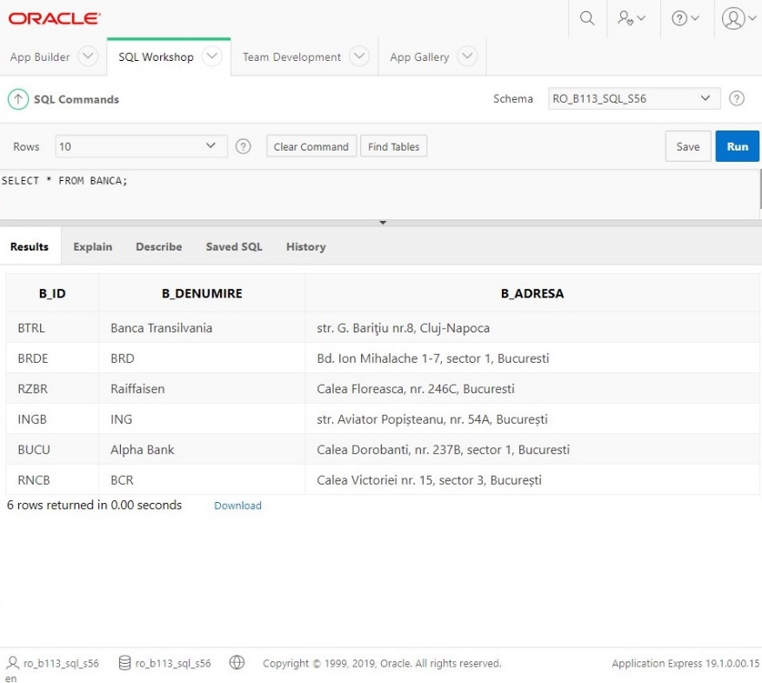

* **Populare tabela Agentie**

INSERT INTO Agentie(a_denumire, a_adresa, a_banca)

VALUES

('Alpha Bank Marasti', 'Strada Fabricii nr. 7, Cluj-Napoca', 'BUCU');

INSERT INTO Agentie(a_denumire, a_adresa, a_banca)

VALUES

('Alpha Bank Zorilor', 'Strada Louis Pasteur, nr. 79','BUCU');

INSERT INTO Agentie(a_denumire, a_adresa, a_banca)

VALUES

('BCR', 'Strada 21 Decembrie, Nr. 16, Cluj-Napoca','RNCB');

INSERT INTO Agentie(a_denumire, a_adresa, a_banca)

VALUES

('BCR', 'Strada Fantanele, Nr. 7, Cluj-Napoca','RNCB');

INSERT INTO Agentie(a_denumire, a_adresa, a_banca)

VALUES

('BT Ferdinand', 'Str. Regele Ferdinand nr. 29, Cluj-Napoca','BTRL');

INSERT INTO Agentie(a_denumire, a_adresa, a_banca)

VALUES

('BT Flora', 'Calea Floresti, Nr. 75, Cluj Napoca','BTRL');

INSERT INTO Agentie(a_denumire, a_adresa, a_banca)

VALUES

('BRD Farmec', 'Strada Henri Barbusse nr. 16','BRDE');

INSERT INTO Agentie(a_denumire, a_adresa, a_banca)

VALUES

('Raiffaisen Brancusi', 'Strada Constantin Brancusi, nr. 149, Cluj Napoca','RZBR');

INSERT INTO Agentie(a_denumire, a_adresa, a_banca)

VALUES

('ING Cipariu', 'Piata Cipariu nr. 11, Cluj Napoca','INGB');

INSERT INTO Agentie(a_denumire, a_adresa, a_banca)

VALUES

('ING Manastur', 'Str. Bucegi nr. 11A, Cluj Napoca','INGB');

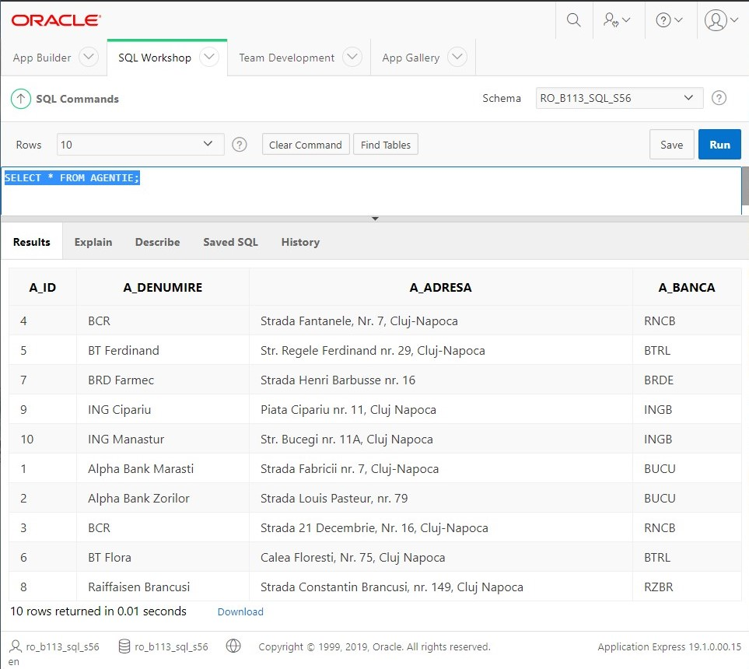

* **Populare tabela ATM**

INSERT INTO ATM(limita_cash, locatie, ATM_banca)

VALUES

(5000, 'Strada Fabricii nr. 7, Cluj-Napoca', 'BUCU');

INSERT INTO ATM(limita_cash, locatie, ATM_banca)

VALUES

(3000, 'Strada 21 Decembrie, Nr. 16, Cluj-Napoca', 'RNCB');

INSERT INTO ATM(limita_cash, locatie, ATM_banca)

VALUES

(5000, 'Str. Regele Ferdinand nr. 29, Cluj-Napoca', 'BTRL');

INSERT INTO ATM(limita_cash, locatie, ATM_banca)

VALUES

(5000, 'Strada Henri Barbusse nr. 16, Cluj-Napoca', 'BRDE');

INSERT INTO ATM(limita_cash, locatie, ATM_banca)

VALUES

(5000, 'Strada Constantin Brancusi, nr. 149, Cluj Napoca', 'RZBR');

INSERT INTO ATM(limita_cash, locatie, ATM_banca)

VALUES

(6000, 'Piata Cipariu nr. 11, Cluj Napoca', 'INGB');

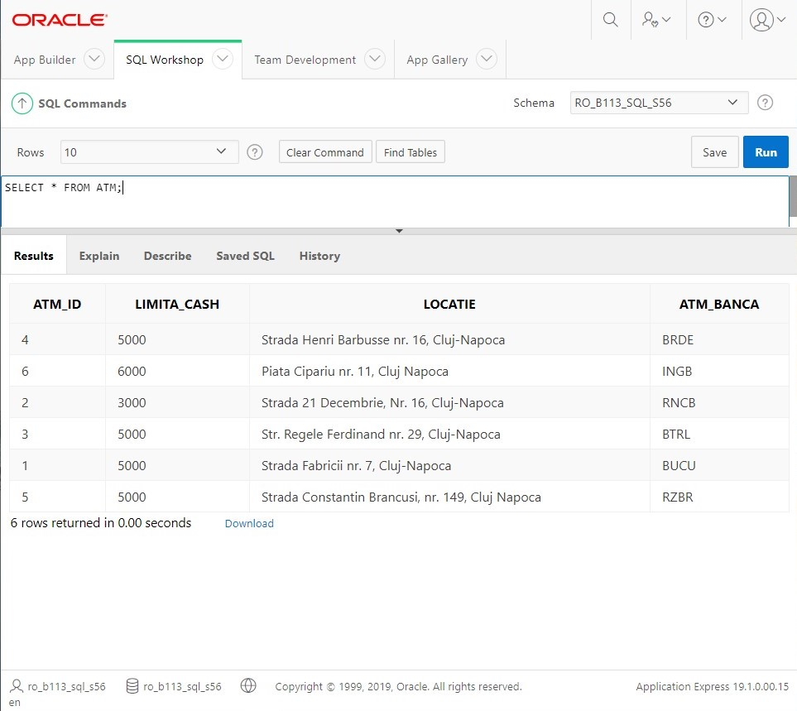

* **Populare tabela Client**

INSERT INTO Client

VALUES

(9876541,'Timis Iulia','Str. Oltului nr 84, Cluj-Napoca', '0756789990','2900908365504');

INSERT INTO Client

VALUES

(1232248,'Stecko Daiana','Str. Crinului nr 7, Cluj-Napoca', '0776843435','2870624015336');

INSERT INTO Client

VALUES

(2436778,'Botezan Vlad','Str. Muresului nr 1, Cluj-Napoca', '0740388093','1941129188640');

INSERT INTO Client

VALUES

(9907211,'Marchis Alexandru','Str. Armoniei nr 5, Cluj-Napoca', '0756786453','5000601519940');

INSERT INTO Client

VALUES

(3445342,'Ghilea Georgiana','Str. Fagului nr 17, Cluj-Napoca', '0722114567','6010708229787');

INSERT INTO Client

VALUES

(6548733,'Tise Tudor','Str. Lunii nr 112, Cluj-Napoca', '0744289556','1971116405094');

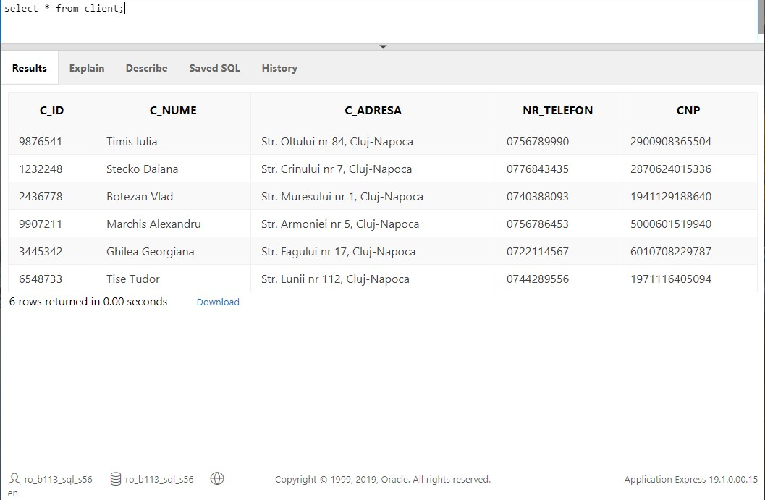

* **Populare tabela Cont**

INSERT INTO CONT

VALUES

('RO49BUCU1223425687934536','LEI','7000','9876541','BUCU');

INSERT INTO CONT

VALUES

('RO30BTRL8767239861276454','EURO','1000','2436778','BTRL');

INSERT INTO CONT

VALUES

('RO30BTRL8767239861276452','LEI','1200','2436778','BTRL');

INSERT INTO CONT

VALUES

('RO17RNCB7623465987012006','LEI','30000','9907211','RNCB');

INSERT INTO CONT

VALUES

('RO78RZBR0004523477859671','EURO','300','1232248','RZBR');

INSERT INTO CONT

VALUES

('RO55INGB0043999452346587','LEI','970','6548733','INGB');

INSERT INTO CONT

VALUES

('RO32BRDE0073699412311589','EURO','2050','3445342','BRDE');

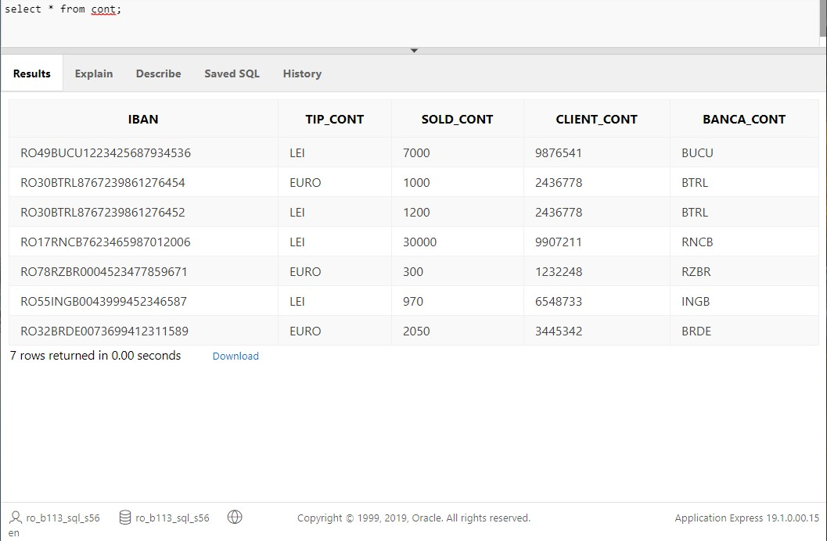

* **Populare tabela Card**

INSERT INTO CARD

VALUES

('4140789065456756','visa','552', to_date('03/22', 'MM/YY'), 2341,'Timis Iulia','RO49BUCU1223425687934536');

INSERT INTO CARD

VALUES

('5678563423654532','visa','222', to_date('03/22', 'MM/YY'), 8642,'Timis Maria','RO49BUCU1223425687934536');

INSERT INTO CARD

VALUES

('3457678498456998','visa','592', to_date('01/23', 'MM/YY'), 9167,'Botezan Vlad','RO30BTRL8767239861276452');

INSERT INTO CARD

VALUES

('1276980956476578','omnipass','983', to_date('04/24', 'MM/YY'), 5761,'Ghilea Georgiana','RO32BRDE0073699412311589');

INSERT INTO CARD

VALUES

('7658324258655875','visa','134', to_date('01/22', 'MM/YY'), 4124,'Tise Laura','RO55INGB0043999452346587');

INSERT INTO CARD

VALUES

('4778554677612345','visa','441', to_date('01/22', 'MM/YY'), 1111,'Tise Tudor','RO55INGB0043999452346587');

INSERT INTO CARD

VALUES

('6754769800658754','mastercard','738', to_date('02/23', 'MM/YY'), 2931,'Stecko Daiana','RO78RZBR0004523477859671');

INSERT INTO CARD

VALUES

('4123453467568765','mastercard','962', to_date('07/25', 'MM/YY'), 7741,'Marchis Alexandru','RO17RNCB7623465987012006');

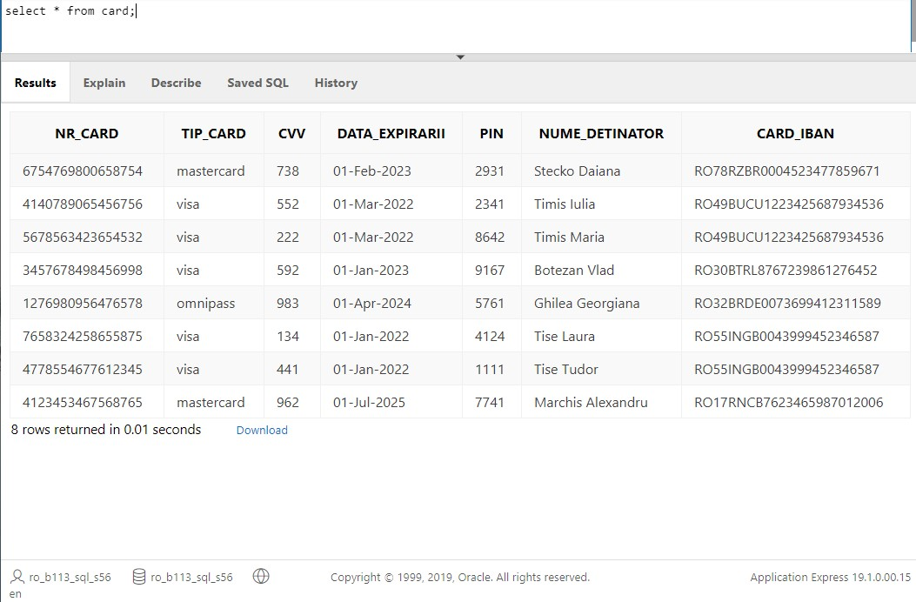

* **Populare tabela Tranzactie**

INSERT INTO Tranzactie(data_ora, tr_tip, tr_valoare, tr_client, tr_ATM)

VALUES

(TIMESTAMP'2021-05-01 17:01:30','retragere numerar', 500,3445342, 1);

INSERT INTO Tranzactie(data_ora, tr_tip, tr_valoare, tr_client, tr_ATM)

VALUES

(TIMESTAMP'2021-05-01 19:00:50','sold cont', NULL, 3445342, 4);

INSERT INTO Tranzactie(data_ora, tr_tip, tr_valoare, tr_client, tr_ATM)

VALUES

(TIMESTAMP'2021-05-02 11:12:39','depunere numerar', 250, 1232248, 5);

INSERT INTO Tranzactie(data_ora, tr_tip, tr_valoare, tr_client, tr_ATM)

VALUES

(TIMESTAMP'2021-05-03 13:54:19','schimbare pin', NULL, 9876541, 1);

INSERT INTO Tranzactie(data_ora, tr_tip, tr_valoare, tr_client, tr_ATM)

VALUES

(TIMESTAMP'2021-05-06 08:01:48','schimb valutar', 450, 6548733, 6);

INSERT INTO Tranzactie(data_ora, tr_tip, tr_valoare, tr_client, tr_ATM)

VALUES

(TIMESTAMP'2021-05-06 20:08:12','retragere numerar', 800, 2436778, 3);

INSERT INTO Tranzactie(data_ora, tr_tip, tr_valoare, tr_client, tr_ATM)

VALUES

(TIMESTAMP'2021-04-10 23:43:18','depunere numerar', 950, 9907211, 2);

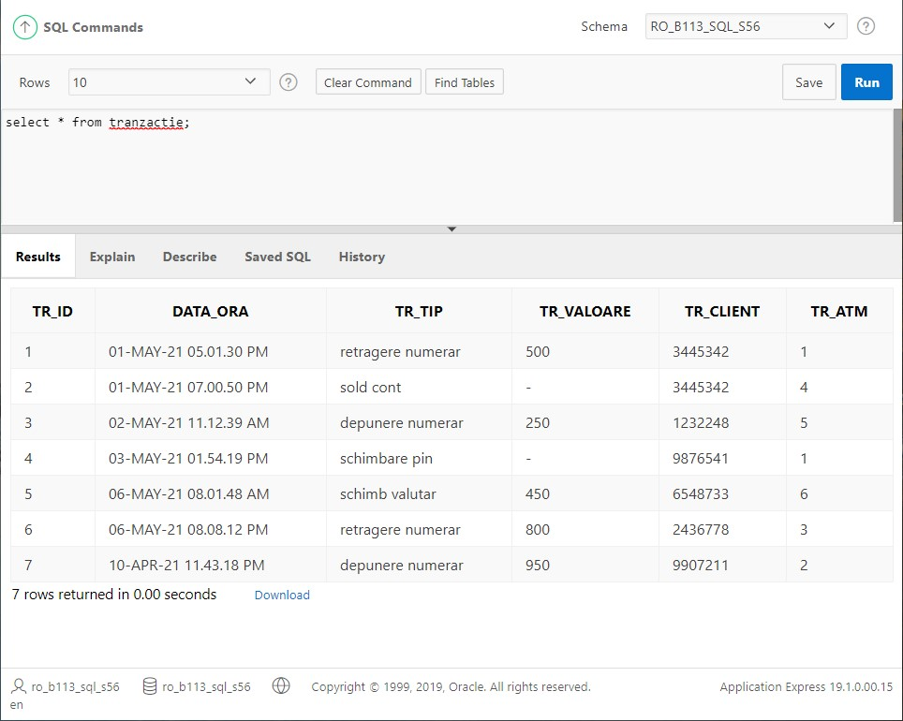

**Modificari de structura**

1.Am sters constrangerea de cheie straina din tabela Card pentru a putea modifica nr de caractere alocat pentru campul card_IBAN.

ALTER TABLE Card

DROP CONSTRAINT Card_FK;

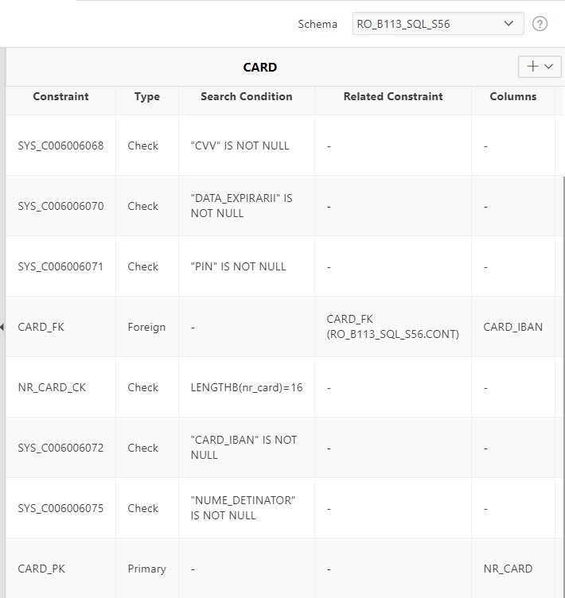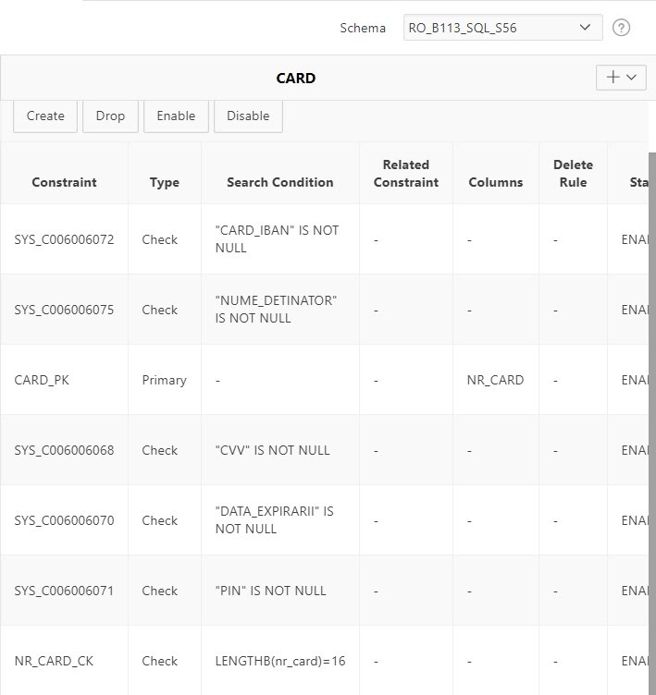

2.Am modificat nr de caractere alocat pentru campul card_IBAN din VARCHAR2(20) in VARCHAR2(40).

ALTER TABLE Card

MODIFY card_IBAN VARCHAR2(40);

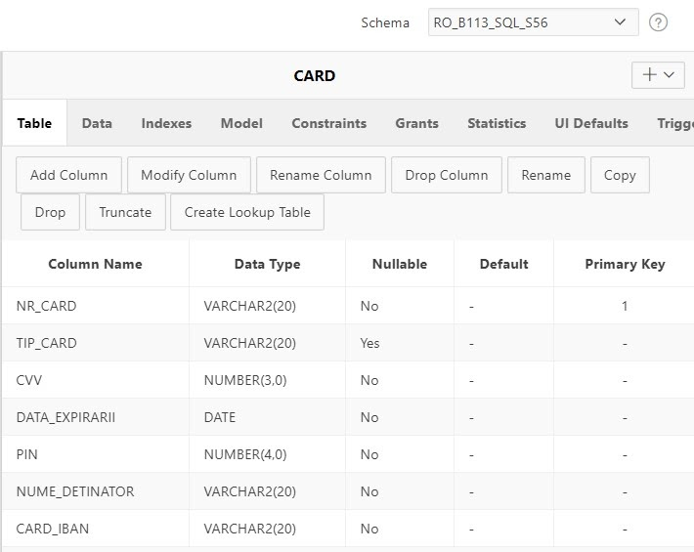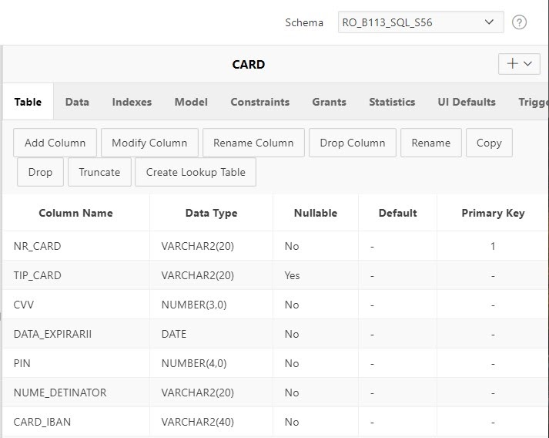

3.La crearea tabelei Tranzactie am omis campul tr_tip.

ALTER TABLE Card

ADD tr_tip number constraint;

4.Am dezactivat constrangerea de tip check din tabela Cont.

ALTER TABLE Card

DISABLE CONSTRAINT NR_CARD_CK;





**Modificari de continut**

1.Se modifica adresa clientului cu codul 9876541 din ‘Str. Oltului 84, Cluj-Napoca’ in ‘Str. Tulcea nr 3, Cluj-Napoca'.

UPDATE Client

SET c_adresa = 'Str. Tulcea nr 3, Cluj-Napoca'

WHERE c_id = 9876541; 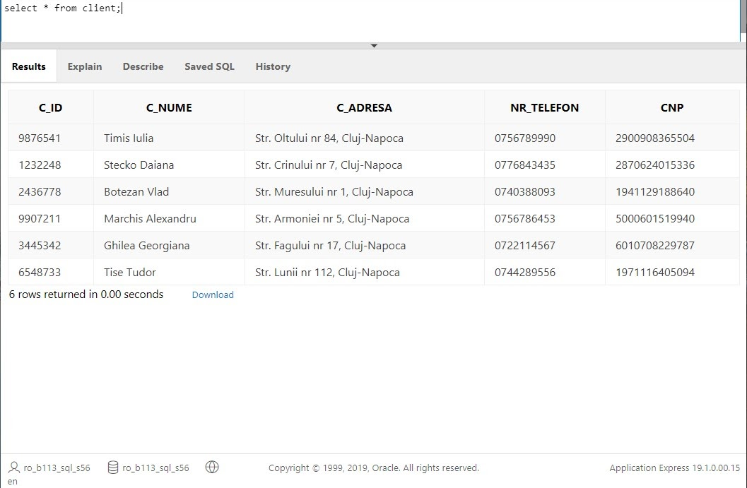

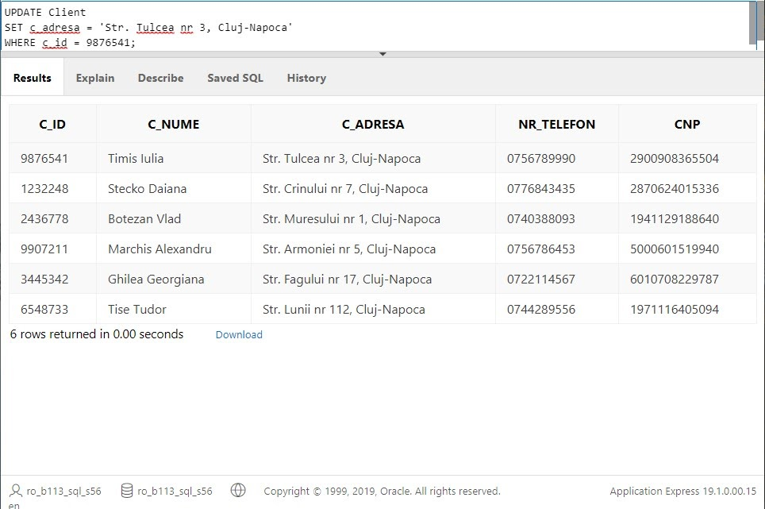

2. Se sterg tranzactiile cu valoare mai mica decat 300.

DELETE FROM Tranzactie

WHERE tr_valoare<300;

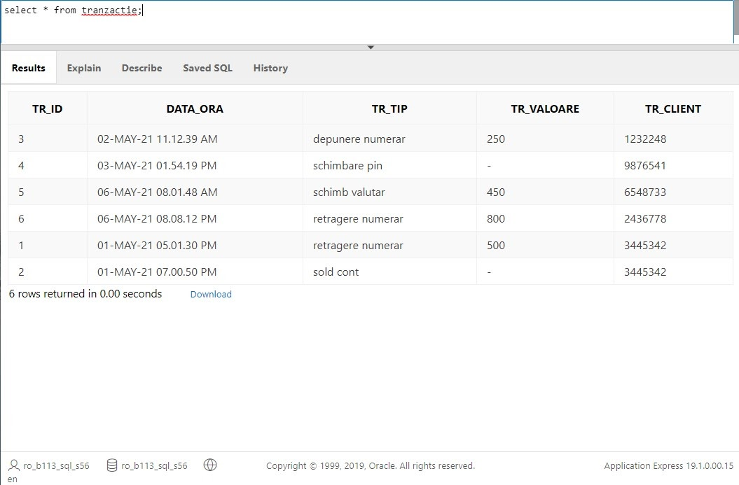

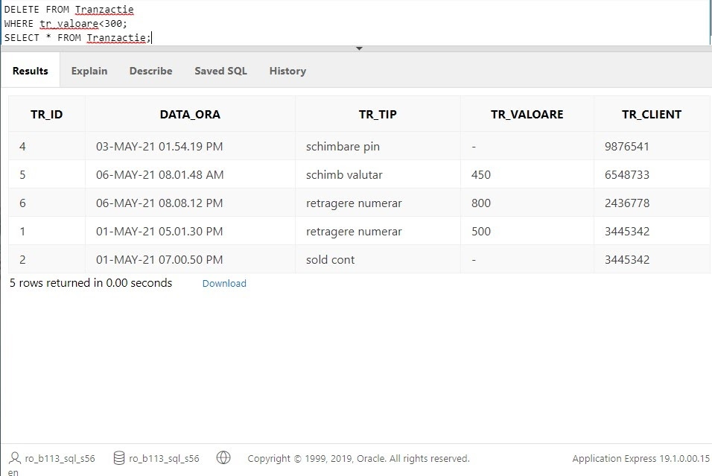

**Vederi**

1.O vedere care contine numele clientului si tipul tranzactiei efectuate pentru clientii care au efectuat o tranzactie mai mare de 300.

CREATE VIEW client_tranzactie AS

SELECT client.c_nume "Nume Client", tranzactie.tr_tip "Tranzactie", tranzactie.tr_valoare "Valoare tranzactie"

FROM client

INNER JOIN tranzactie

ON client.c_id = tranzactie.tr_client

WHERE tranzactie.tr_valoare>300;

SELECT * FROM client_tranzactie;

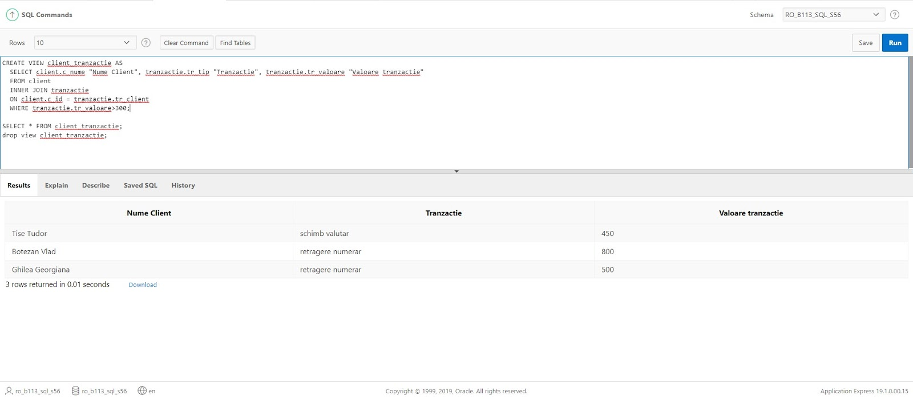

2.O vedere care contine toate conturile, soldul si detalii despre titularii acestora.

CREATE VIEW client_cont AS

SELECT cont.iban, client.c_nume "Nume client", client.nr_telefon "Numar telefon", cont.sold_cont "Sold cont"

FROM client

INNER JOIN cont

ON client.c_id = cont.client_cont;

SELECT * FROM client_cont;

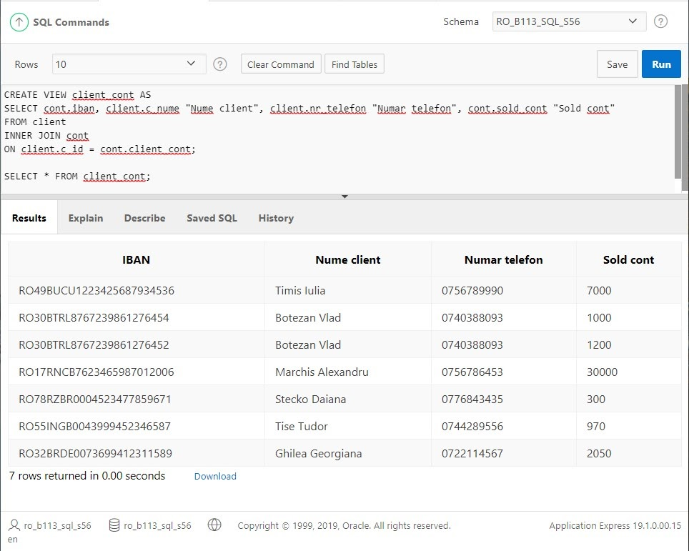

3.O vedere care contine numele bancii, numele si adresa agentiilor si locatia atm-urilor.

CREATE VIEW banca_atm_agentie

AS SELECT banca.b_denumire "Banca", agentie.a_denumire "Agentia", agentie.a_adresa "Adresa agentie", atm.locatie "Locatie ATM"

FROM banca, agentie , atm

WHERE banca.b_id=agentie.a_banca

AND banca.b_id=atm.ATM_banca;

SELECT * from banca_atm_agentie;

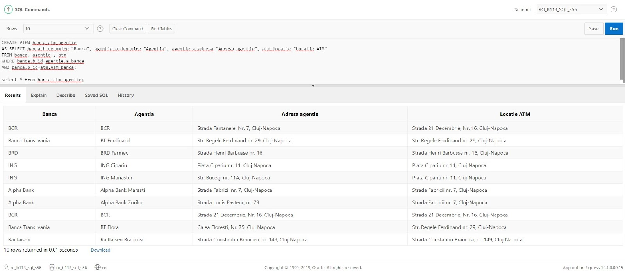

**Interogari**

1.Contul IBAN al clientilor care au cardul cu data expirarii pana in anul 2022 inclusiv.

SELECT

    IBAN

FROM

    cont

WHERE IBAN in( select card_iban from card

WHERE EXTRACT(YEAR FROM TO_DATE(data_expirarii, 'dd/mm/yyyy')) <=2022

);

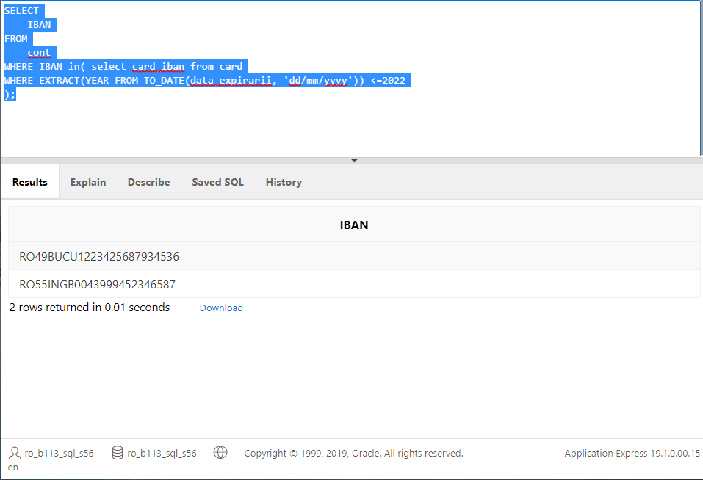

2.Contul IBAN al clientilor care au cardul cu data expirari dupa anul curent .

SELECT

    IBAN

FROM

    cont

WHERE IBAN in( select card_iban from card

WHERE EXTRACT(YEAR FROM TO_DATE(data_expirarii, 'dd/mm/yyyy'))>EXTRACT(YEAR FROM SYSDATE)

);

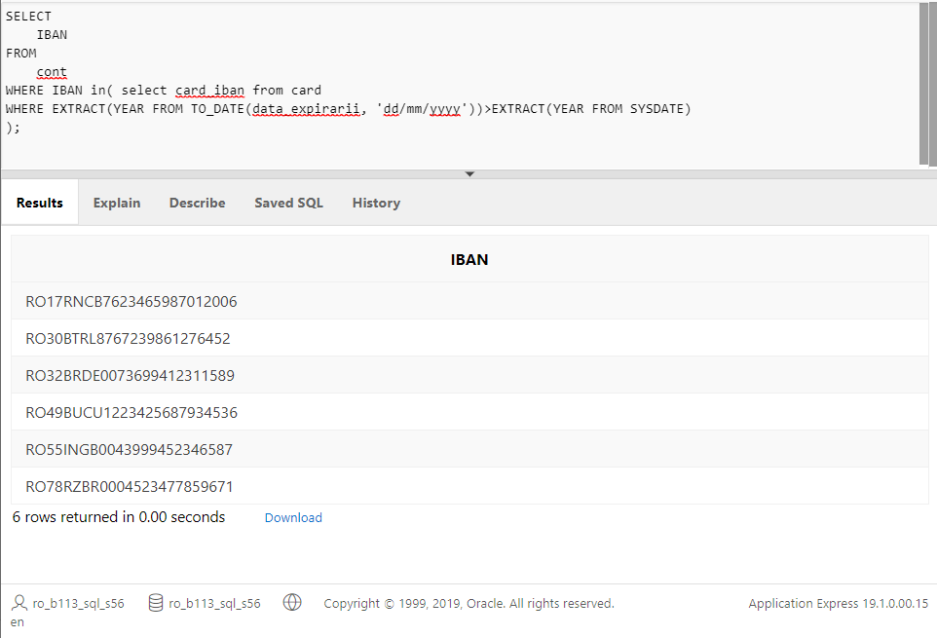

3.Nume clienti care au mai mult de un cont deschis.

SELECT c_nume

FROM client

WHERE c_id IN ( SELECT client_cont  FROM cont

GROUP BY client_cont

HAVING COUNT(distinct iban)>1

 );

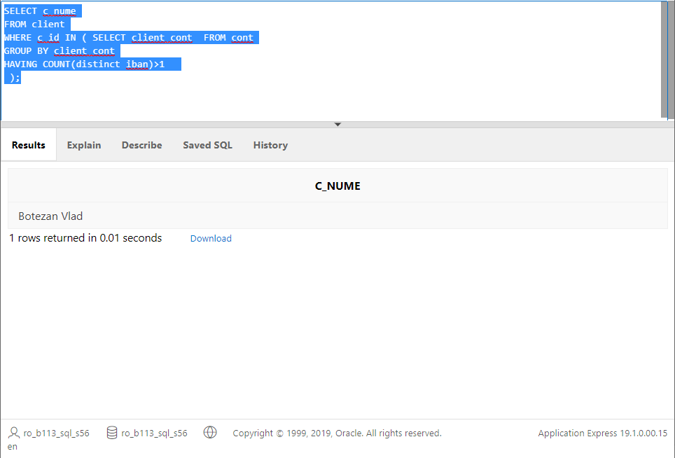

4. IBAN ul conturilor cu cel putin 2 carduri visa.

SELECT iban

FROM cont

WHERE iban in (SELECT card_iban FROM card

WHERE tip_card='visa'

GROUP BY card_iban

HAVING COUNT(nr_card)>1

);

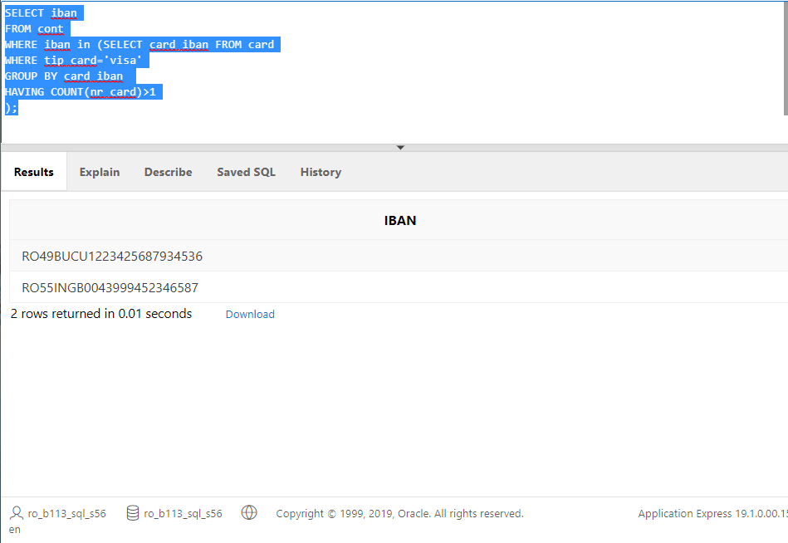

5.Nr de telefon si numele clientilor care au facut o retragere mai mare de 500.

SELECT

    c_id, c_nume, nr_telefon

FROM

    client

WHERE c_id in

        (SELECT tr_client FROM tranzactie

WHERE tr_tip='retragere numerar' AND tr_valoare>500

GROUP BY tr_client

    )

ORDER BY

    c_id;

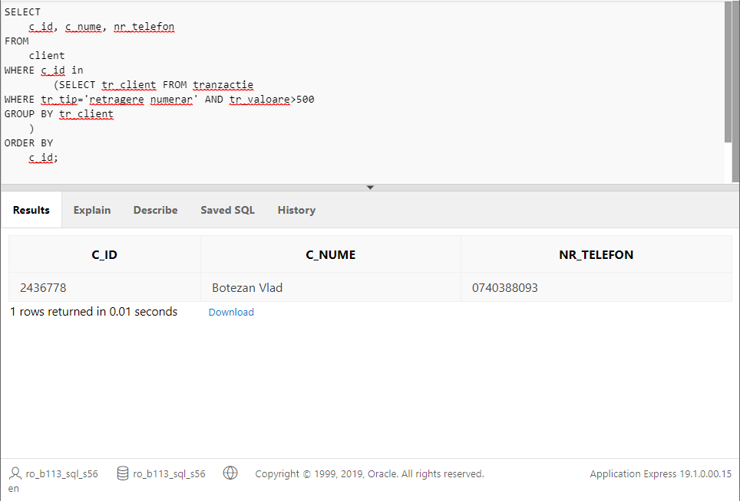

6. IBAN urile conturilor si soldul acestora pentru conturile care au soldul mai mare decat media de pe coloana.

SELECT

    iban, sold_cont

FROM

    cont

WHERE

     sold_cont> (

        SELECT

            AVG( sold_cont)

        FROM

            cont

    )

ORDER BY

    iban;

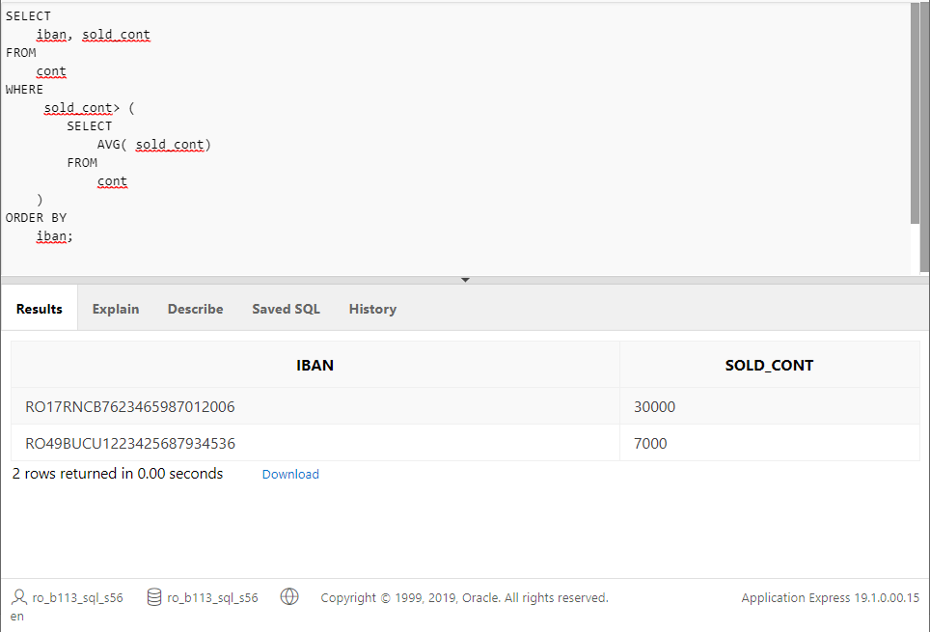

7. IBAN si soldul pentru contul cu cel mai mare sold disponibil.

SELECT

    IBAN, sold_cont

FROM

    cont

WHERE

    sold_cont = (

        SELECT

            MAX( sold_cont )

        FROM

            cont

    );

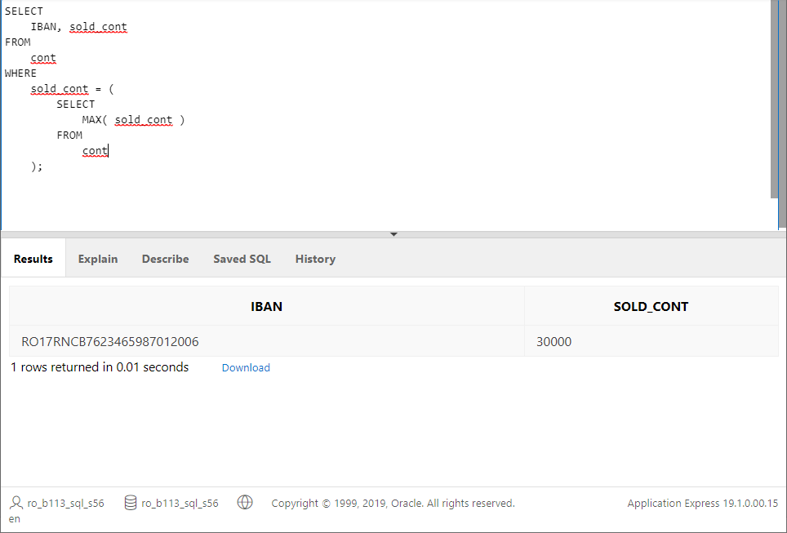

8. Nume client care are cel mai mic sold disponibil.

SELECT

    c_id, c_nume

FROM

    client

WHERE c_id in( SELECT client_cont FROM cont

WHERE sold_cont = (

        SELECT

            MIN( sold_cont )

        FROM

            cont)

    );

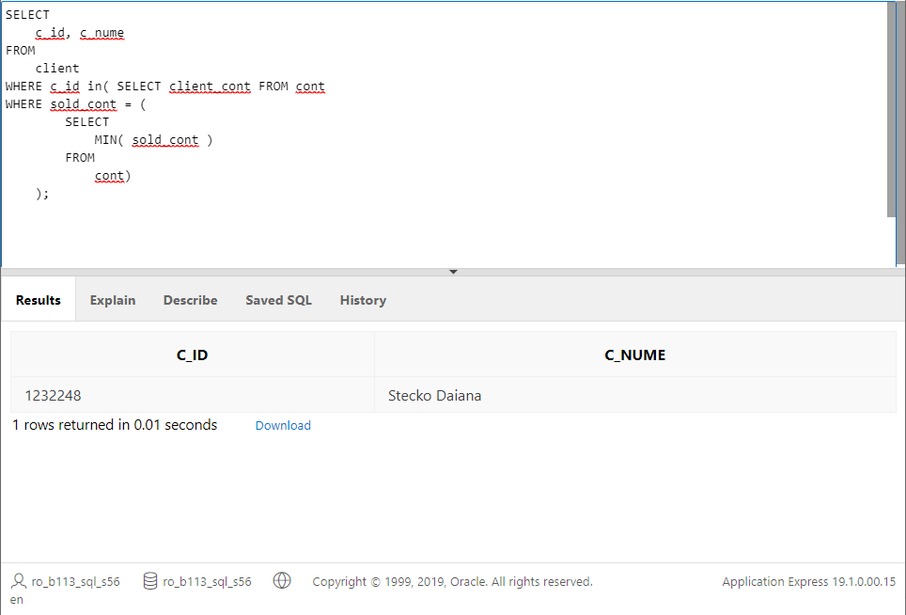

9. Denumirea bancilor care au ATM care nu are limita mai mare de 5000.

SELECT b_id, b_denumire FROM banca

WHERE b_id NOT IN(SELECT ATM_banca FROM ATM

WHERE limita_cash>5000

);

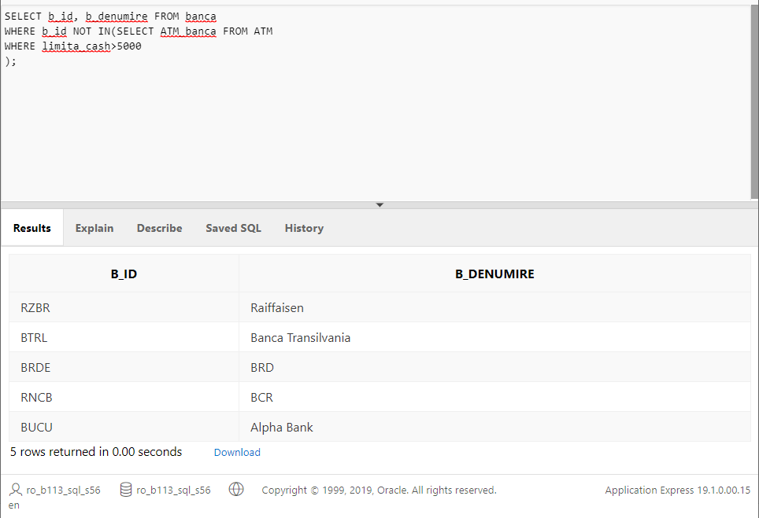

10. Denumirea bancilor care au ATM uri in Cluj-Napoca.

SELECT b_id, b_denumire FROM banca

WHERE b_id IN (select ATM_banca FROM ATM

WHERE REGEXP_LIKE (locatie, 'Cluj Napoca') OR REGEXP_LIKE (locatie, 'Cluj-Napoca')

);

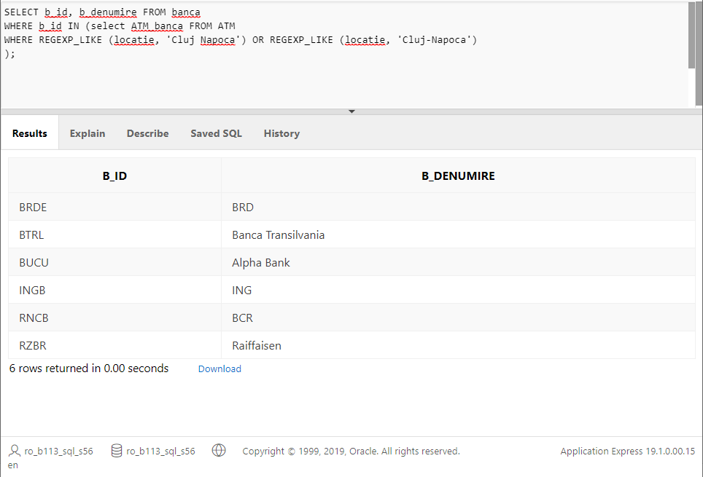

11.Locatiile ATM urilor la care au fost efectuate tranzactiile din 01/05/2021.

SELECT atm_id, locatie FROM atm

WHERE atm_id in (SELECT tr_atm FROM tranzactie

WHERE to_date(to_char(data_ora,'dd/mon/yyyy'))='01 may 2021'

);

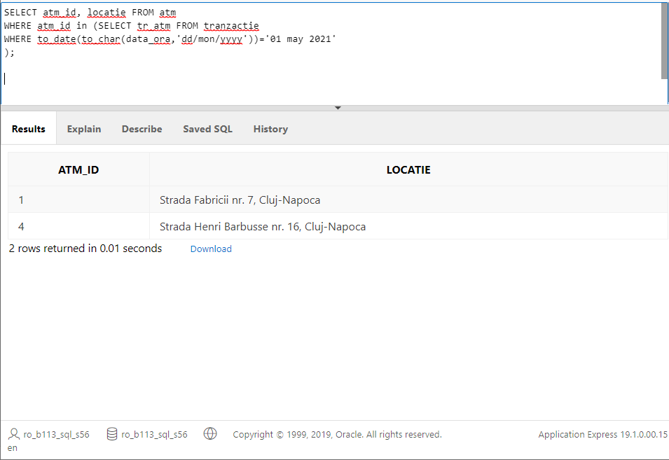

12.Locatiile ATM urilor la care au fost efectuate tranzactiile din intervalul 01/05/2021-31/05/2021.

SELECT atm_id, locatie FROM atm

WHERE atm_id IN (SELECT tr_atm FROM tranzactie

WHERE to_date(to_char(data_ora,'dd/mon/yyyy')) BETWEEN '01 may 2021' AND '31 may 2021'

);

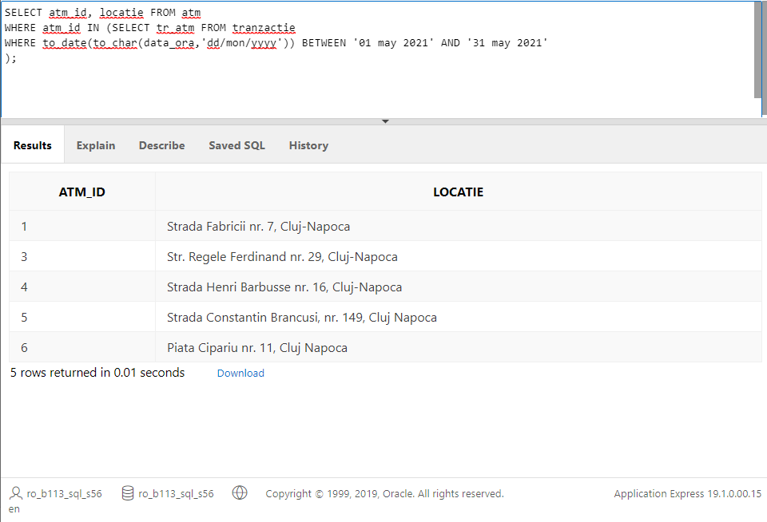

13.Bancile ordonate crescator dupa nr de conturi deschise.

SELECT b.b_id, count(c.iban) AS Nr_conturi

FROM banca b JOIN cont c ON b.b_id = c.banca_cont

GROUP BY b.b_id

ORDER BY Nr_conturi ASC;

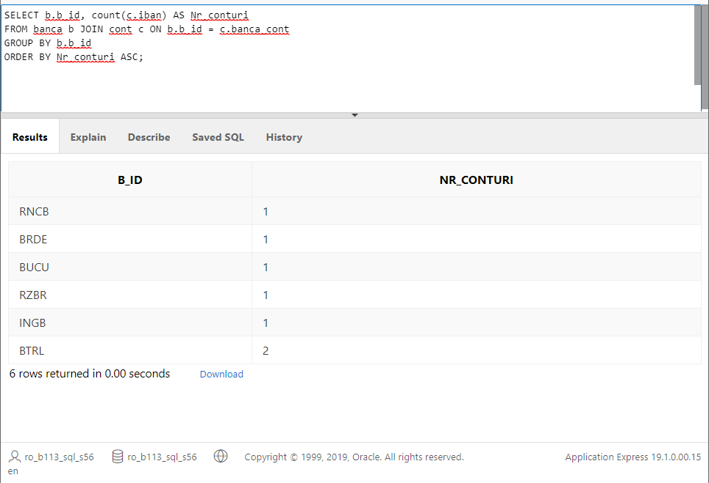

14.Clientii ordonati descrescator dupa nr de tranzactii efectuate.

SELECT c.c_id, count(t.tr_id) AS Nr_tranzactii

FROM client c JOIN tranzactie t ON c.c_id = t.tr_client

GROUP BY c.c_id

ORDER BY Nr_tranzactii DESC;

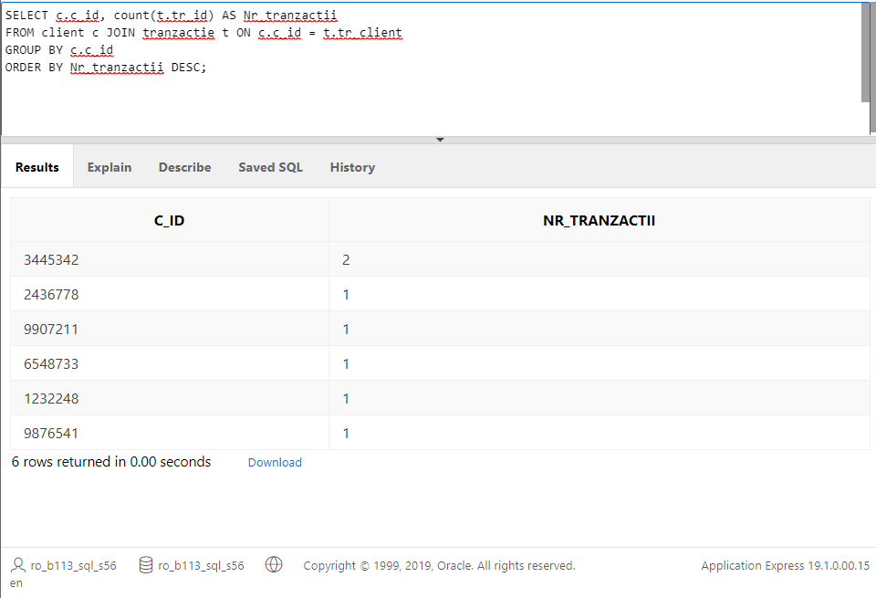

15. Nume clienti care au efectuat un alt tip de tranzactie decat retragere si depunere numerar.

SELECT c_nume FROM client

WHERE c_id IN (SELECT tr_client FROM tranzactie

WHERE tr_tip<>'retragere numerar' AND tr_tip<>'depunere numerar');

`